**Lab #6 – Upload Site Files to Web Host**

**Part A.**

Create Profile at W3 Schools:

Create a new page and upload files to Space:

Preview your site and screenshot each page:

Home Page:

About Us Page:

Contact Us Page:

Thank You Page:

Ensure your site is live and list the full site name: URL: <https://lab6khan.w3spaces.com/>

**Part B.**

Navigate the WordPress Admin Dashboard and Screenshot:

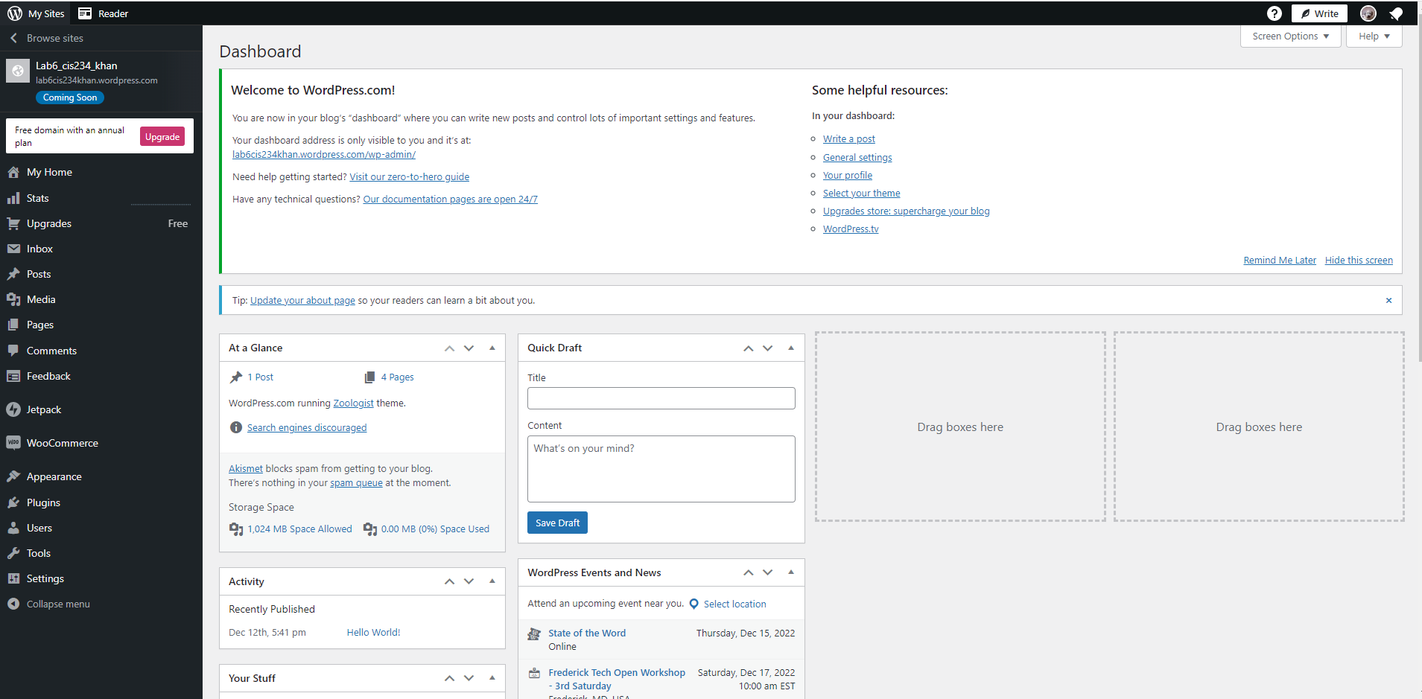

In the pages section, create a new blank page and name it. Repeat for each page. Screenshot:

Index (Home):



Contact Us:



About Us:



Thank You:



All of the Pages in the Dashboard:

Click add block, click add a file block, navigate to the html file you are uploading. Repeat each step until all you have successfully uploaded all site pages. Take a screenshot of the content of the files uploaded in WP (WordPress):

Home/Index site on WP:

Contents of the Index HTML File:

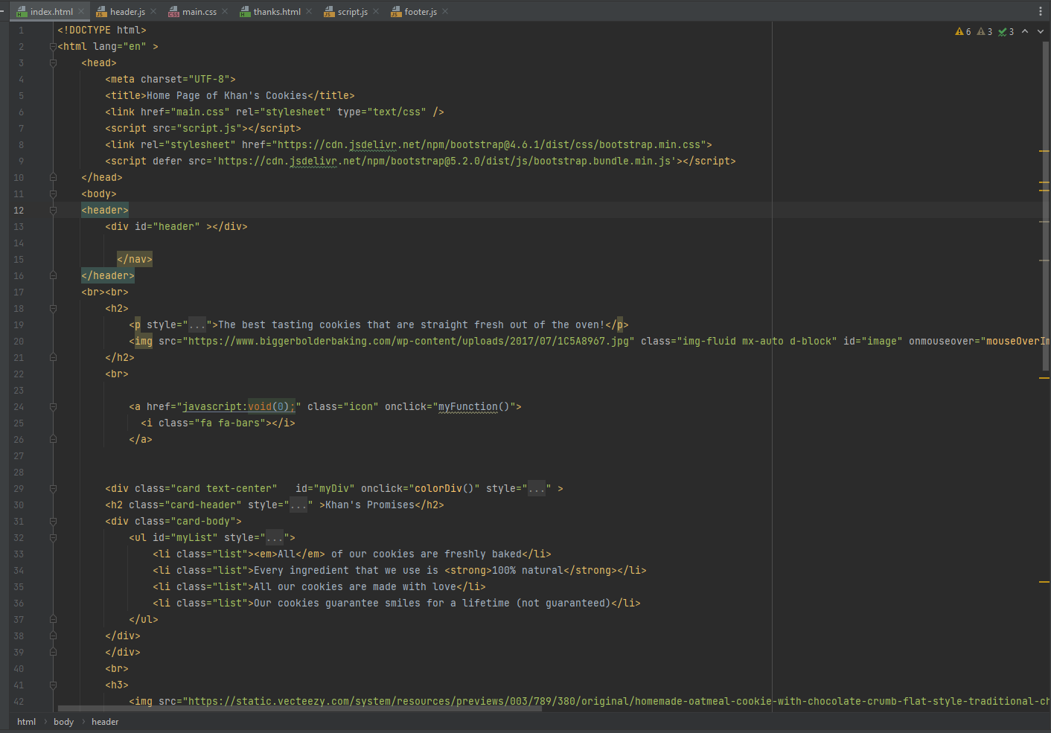

Contact Us site on WP:

Contents of Contact Us HTML file:

About Us site on WP:

Contents of About Us HTML File:

Thank You site on WP:

Contents of Thank You HTML File:

Add In the JS Scripts:

Navigate to the FSE (Full Site Editor) in WordPress. Add in your CSS:

Website URL:  
https://dev-lab6cis234.pantheonsite.io/